

Hotel Management SYSTEM

**|Introduction to Database | 17.04.2019**

**Members:**

**1.Farhan Masud**

**2.Md Ibrahim Hossain Rifat**

**3.Karunnah Nahar**

**4.Nahidul Islam**

**Contents**

1. ***Project Overview***
2. ***ER Diagram***
3. ***Normalization***
4. ***Description of tables***
5. ***Queries***
6. ***Summary***

***Project overview***

**In our project on ‘Hotel management system’ we have tried to show how a hotel is managed. This is just an overview of management in hotels. Staffs of the hotels works for the clients who stay or visit their Hotel. All the information of the staffs are recorded in the database of the hotel. And the information of the Clients are also recorded in the database of that hotel. After staying or visiting the hotel clients give feedback or clients evaluate the hotel. Their evaluations are also recorded. Staffs are evaluated by the clients. Our project includes information for staffs, clients and the feedbacks. We have included only few modules. By adding more modules this type of project can be used in various hotels.**

**ER Diagram**

STAFF

Works

for

Are evaluatedby

CLIENT

Gives

FEEDBACK

**Normalization**

First Normal Form:

In these tables there is no multivalued attributes and every attribute value is atomic.

Second Normal Form:

|  |  |  |  |  |  |
| --- | --- | --- | --- | --- | --- |
| ID | Name | Address | Email | Contact Number | Room_no |
| 3001 | Rakib | Mirpur | rakib@gmail.com | 01552496100 | 901 |
| 30023 | Joy | Tejgaon | Joy@gmail.com | 01552496101 | 902 |
| 3003 | Rifat | Farmgate | rifat@gmail.com | 01552496102 | 903 |
| 3004 | Partho | Dhanmondi | partho@gmail.com | 01552496103 | 904 |
| 3005 | Pritam | Mohammadpur | pritam@gmail.com | 01552496104 | 905 |

|  |  |
| --- | --- |
| Room_no | Room_Type |
| 901 | double |
| 902 | singles |
| 903 | doubled |
| 904 | single |
| 905 | delux |

**Third Normal Form:**

**Tables**

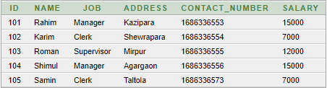

**STAFF Table**

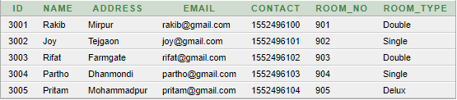

**CLIENT Table**

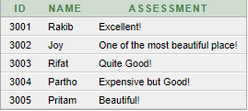

**FEEDBACK Table**

**QUERIES**

**1.**

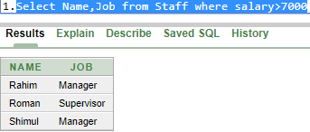

2.

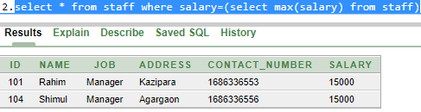

**3.**

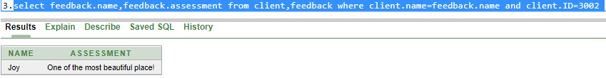

**4.**

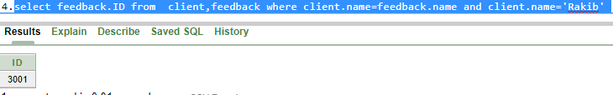

**5.**

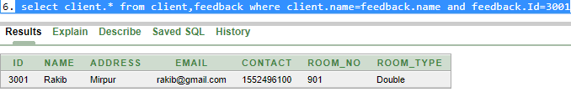

**6.**

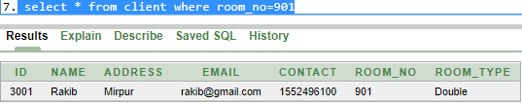

**7.**

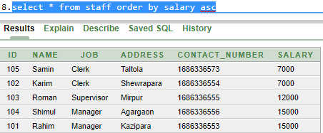

8.

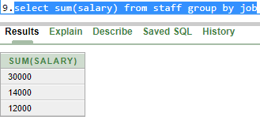

**9.**

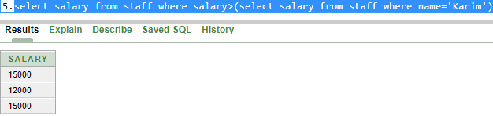

**10.**

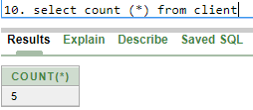

**Summary**

**We have learned so many things from this database project on hotel management system. We have faced a lot of difficulties. It was not so easy. Our main problem was Normalization. But without normalization it was a pretty good experience for us.**